

Zwischen

The Car Sharing Application

User’s Manual

CEN 3031 CRN 80594 - R

Software Engineering Fundamentals

Thursday 3:

Brandon Davis

Zachary Greening

Gage Kettering

Tyler Marlow

Charles Taylor

**USER’S MANUAL**

**Table of Contents Page**

1. General Information………………………………………………………………...…
   1. General Information
   2. Overview
2. Installation…………………………………………………………………………..…
   1. How to Download and Install the JAR file
   2. System Requirements
3. Create an Account……………………………………………………………………..
   1. Creating your Account
   2. Logging in
4. How to use……………………………………………………………………………..
   1. Home Screen
   2. Map
   3. Driver Weekly Schedule
   4. Request Ride
   5. Messaging
   6. Notifications
   7. Friends List
   8. Ride History
   9. Edit Account
5. Closing the Application………………………………………………………………..
   1. Closing the Application
6. Support…………………………………………………………………………...…....
   1. Crashing
   2. Unresponsive
   3. Tech Support

**1. General Information**

***1.1 General Information***

The Zwischen Car Sharing Application is a team project for our Software Engineering Fundamentals class of Fall 2018. We are in the Thursday class, we are team 3, and we were designated to make a ride sharing application.

***1.2 Overview***

The Zwischen application is a desktop application that will allow for easy carpooling. This manual is designed to help a Zwischen user operate our product with ease. The manual will explain the application as well as the functions in it. Our program will allow the user to create their account (with username, password, email address, and telephone number). Once an account is created, the credentials are then stored into a database. A user can close and reopen the program and will be able to login with their account credentials. The user will then be able to set their weekly schedule as a driver, this information will be displayed to anyone looking for a driver. In addition, a user can request a ride to a location local to the user. User’s will then have the ability to message each other to communicate about upcoming rides. The user will receive the message as a notification and can reply to said message, mark it as read, mark it as unread, and delete the message from the message window. A user can also interact with a WebView map to search for destinations.

**2. Installation**

***2.1 How to Download and Install the JAR file***

-Download the Jar file

-Double click the jar file:

**Zwischen.jar**

-This will start the program from the login screen.

- In order for the program to run successfully, lib folder MUST be in the same folder as Zwischen.jar

***2.2 System Requirements***

* System requirements:
  + Mac OS, Linux, Windows XP or higher
  + Internet Connection
  + Latest version of Java

**3. Create an Account**

***3.1 Creating your Account***

In order for a user to create an account, they must begin with pressing the “Create Account” button located at the bottom of the login screen. The user will be redirected to the “Create Account” screen where they must enter a valid username that is not the same as a current user within the database. The username must be digits and/or letters and must span at minimum 5 characters. The username cannot be “login”. Next, the user must enter their desired password, a password must be digits and/or letters, and will at minimum need to span 5 characters. The application will then request the user to confirm their password, this will check to see if the user entered the same password in both input fields. The user will then be required to enter a valid email address, containing an “@” symbol followed by the domain. Lastly, the application will request a user phone number, the phone number may be typed in any phone number format as long as there are ten digits as input. The application will then require the user to press the “Create Account” button, this will also log the user in and direct them to the main screen of the Zwischen Car Sharing App. 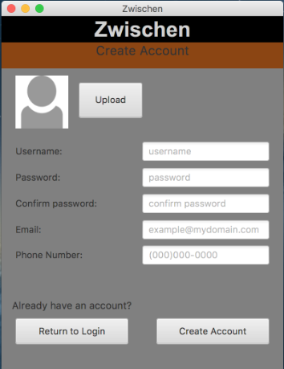

***3.2 Logging in***

If a user has created an account in the past, the user will have the capability to “Login”. When the application is initiated, the login screen will prompt a user to enter in their predefined username and password, followed by pressing the “Login” button located towards the bottom of the screen.

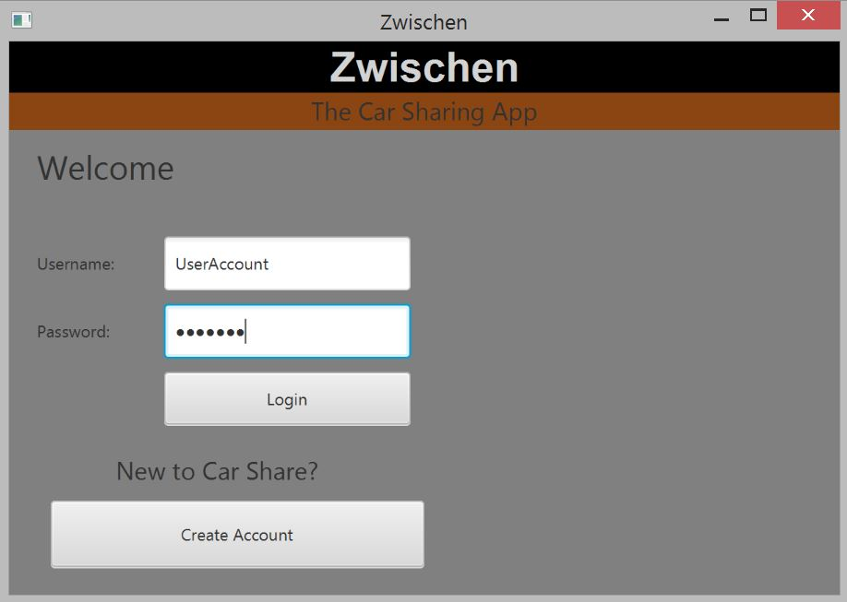

**4. How to use**

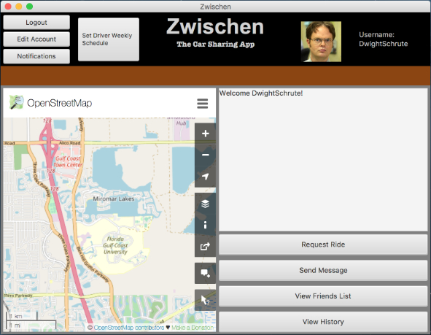

***4.1 Home Screen***

From the home screen of the application, the following components will be generated. A WebView map on the left side of the screen and to the right, the application will display a user’s recent notifications. In the upper left corner of the screen, the application will display four buttons: “Logout”, “Edit Account”, “Notifications”, and “Set Driver Weekly Schedule”. The bottom right corner will display four more buttons: “Request Ride”, “Send Message”, “View Friends List”, and “View History”. The eight buttons located on the home screen will redirect the user to the desired page.

***4.2 Map***

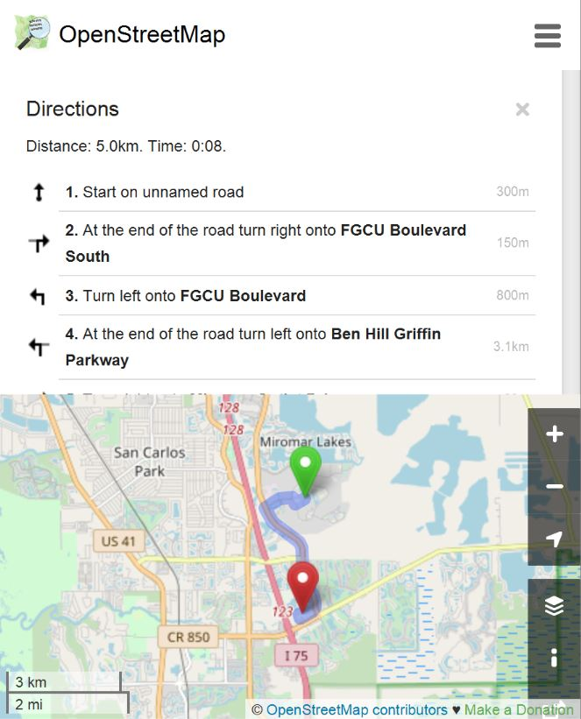 Our WebView will load in the URL,

<https://www.openstreetmap.org/directions#map=13/>

[26.4694/-81.7750](https://www.openstreetmap.org/directions#map=13/%2026.4694/-81.7750), this map is the OpenStreetMap API. In the top right corner of the map, there will be three horizontal lines stacked vertically, if you click this, the map will allow for the user to enter two locations: a “From” location, this is your starting location. There will also be a “To” location, this will be the destination you wish to travel to. If the user enters valid addresses, the WebView will give directions to the two locations.

***4.3 Driver Weekly Schedule***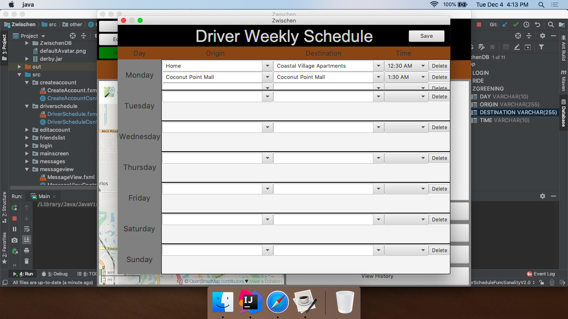

The “Driver Weekly Schedule” window is where a user will have the capability to fill out their weekly schedule (Monday - Sunday), with times and places they will be driving. The driver will need to declare three fields (Origin location, Destination location, and Time they plan to arrive to the destination location), followed by pressing the “Save” button in the top right of the screen. Once the “Save” button is clicked, the information will be saved to the database. If a driver would like to remove their schedule, they can press the “delete” button and this will clear the information entered from the user for that select row of information.

***4.4 Request Ride***

The “Request Ride” window will load the information entered by the drivers from the “Driver Weekly Schedule”. The user must enter the location they are looking to be picked up from, the location they are looking to be dropped off at, and the time they wish to arrive at the destination location, the user will click the “Search” button and the screen will display the information of all drivers in the local area. When the user has selected their desired driver, the user will click the “Submit” button and that will mark them as riding with the said driver. 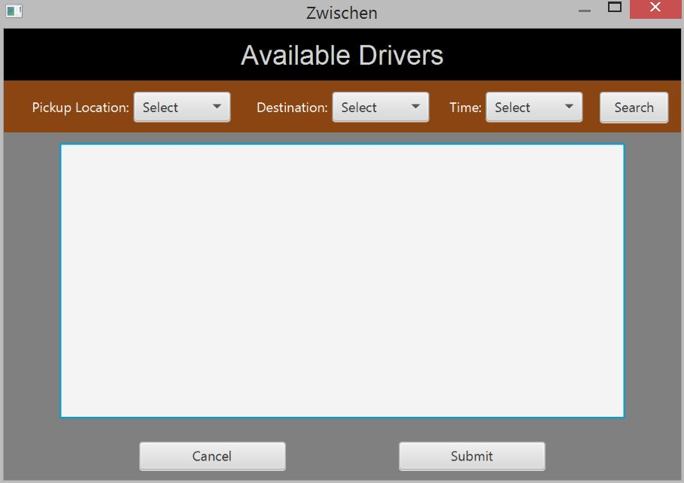

***4.5 Messaging***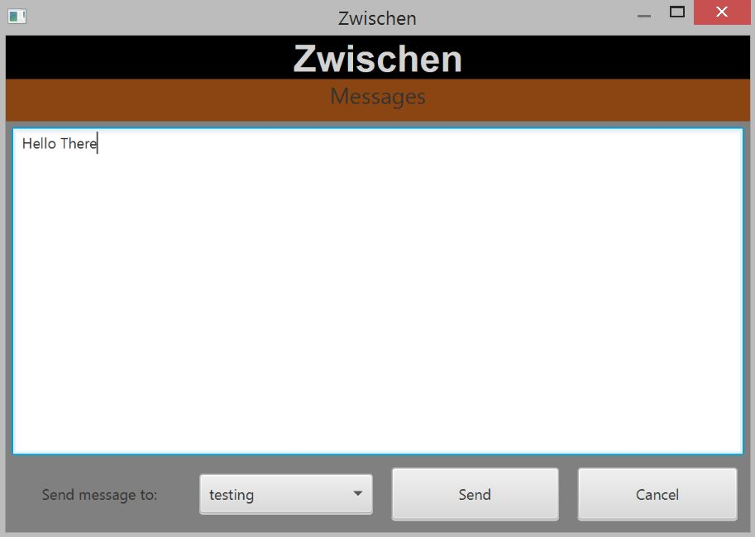

The messaging screen will allow a user to compose a message that will be sent to the desired recipient. The user will begin by composing their message, followed by selecting who they would like the message to be delivered to, lastly the user will have to make the decision on whether or not they would like to send the message. The “Send” button will deliver the message to the other user. The “Cancel” button will close the screen and redirect the user back to the “Home Screen”.

***4.6 Notifications***

When a user receives a new notification, the “Notifications” button will turn green. After clicking the “Notifications” button, the “Notifications” window will open, this window will display all new messages received from other users. Each message will have a check box displayed to the right, the checkbox is used for: marking messages as read, marking messages as unread, and to delete messages. The “Return” button in the bottom left portion of the window will redirect the user back to the “Home Screen”. If a user clicks on the message, four buttons will be displayed: “Reply”, this will allow the user to send a message back to the sender. There will be a “Mark as Read” button that will remove the blue circle, and no longer display the message as “New”. The “Delete” button will remove the message from the users “Notifications” window. The “Return” button will close the message that is currently being displayed and display the user’s notifications. 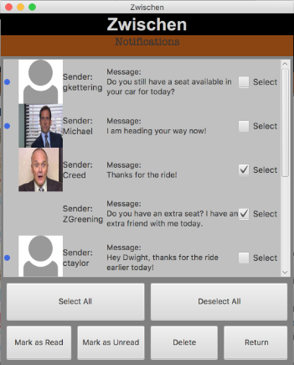

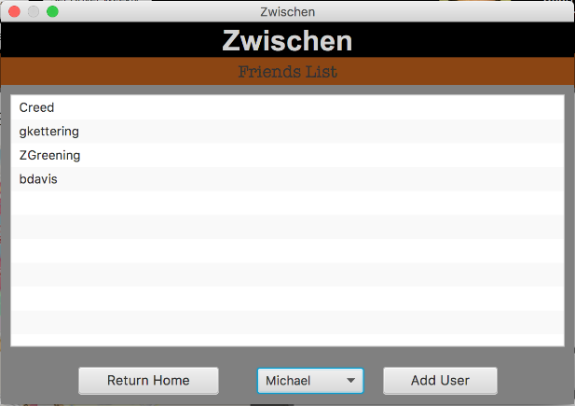

***4.7 Friends List***

When a user clicks on the “View Friends List” button, they will be redirected to the “Friends List” window, this window will display all users that you have previously added. This window will also have a drop-down box with all usernames that are stored on the database. When a user selects a name from the list and clicks the “Add User” button, the name will then be displayed in the window.

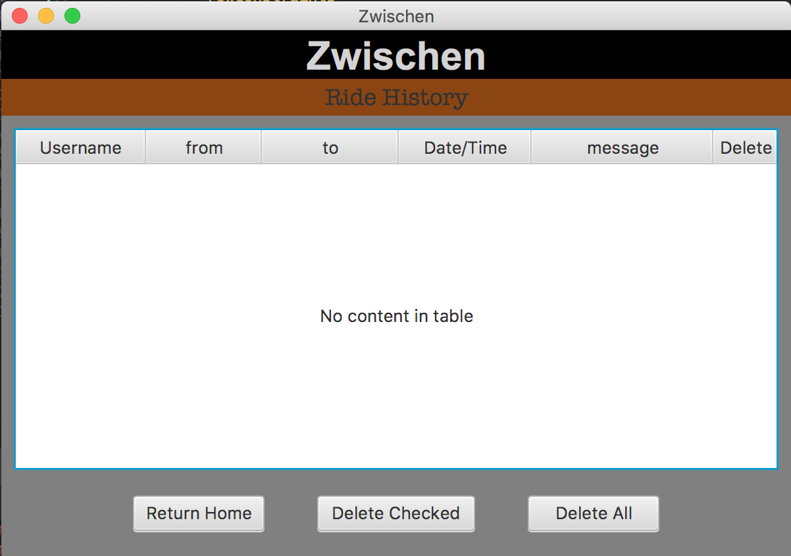

***4.8 Ride History***

The “Ride History” window will display information based on the rides that were previously accepted. A user will have the capability to delete specific rides in history, alternatively, a user can clear their entire history, using the “Delete All” button in the bottom right of the screen.

***4.9 Edit Account***

A user has the capability to edit previously confirmed information about their account. A user cannot change their username, but are able to change their password, phone number, email address, and profile picture. After a user has entered in all the information they would like to edit, they will click the “Update Account” button in the bottom right, this will save the users new information within the database. If a user clicks “Return to Main Screen”, the program will redirect the user back to the “Home Screen”.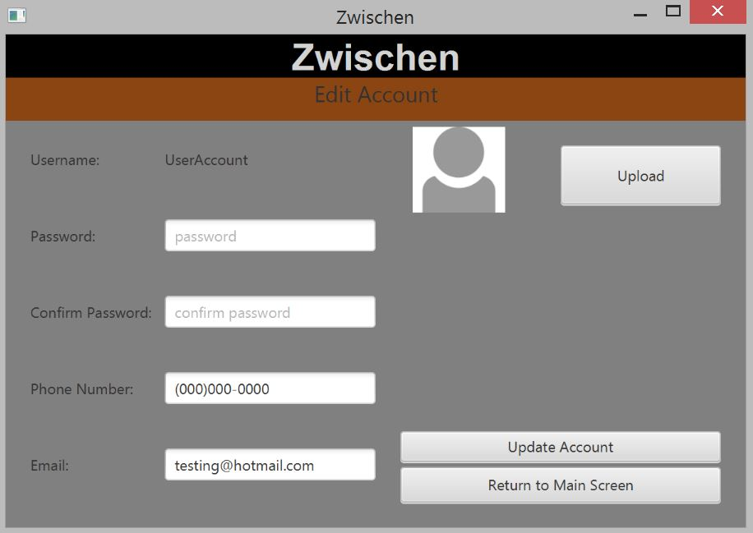

**5. Closing the Application**

***5.1 Closing the Application***

When a user has concluded their experience with the app, the user will click the “Logout” button in the top left of the application, this will redirect the user back to the login page. After logging out, the user can press the red “X” in the top corner of the browser, this will close the Zwischen Car Sharing application.

**6. Support**

***6.1 Crashing***

If the program crashes, run the executable **Zwischen.jar** file to reopen. The login window will appear on the screen.

***6.2 Unresponsive***

If the program stops responding, open the task manager and end the **Zwischen.jar** program. The program can be reopened by running the executable **Zwischen.jar** file.

***6.3 Tech Support***

●Gage Kettering | gdkettering2062@eagle.fgcu.edu

●Brandon Davis | btdavis3378@eagle.fgcu.edu

●Tyler Marlow | tjmarlow5889@eagle.fgcu.edu

●Charles Taylor | cftaylor7218@eagle.fgcu.edu

●Zachary Greening | zjgreening3328@eagle.fgcu.edu